# **Name: Abdurrahman Qureshi**

# **Roll No: 210451**

Practical No: 1

**1)Demonstrate the use of Radio box and Checkbox**

**CODE:**

import java.applet.*;

import java.awt.*;

// <applet code="Main" height=200 width=200></applet>

public class Main extends Applet {

CheckboxGroup myCheckBoxGroup;

Checkbox c1, c2, c3, c4;

Label l1, l2;

public void init() {

l2 = new Label("Abdurrahman Qureshi - 210451\n\n");

l1 = new Label("This is an AWT Label\n\n");

c1 = new Checkbox("Lion", false);

c2 = new Checkbox("Shark", true);

c4 = new Checkbox("Vulture", false, myCheckBoxGroup);

c3 = new Checkbox("Cobra", true, myCheckBoxGroup);

add(l1);

add(l2);

add(c1);

add(c2);

add(c3);

add(c4);

}

}

**OUTPUT:**

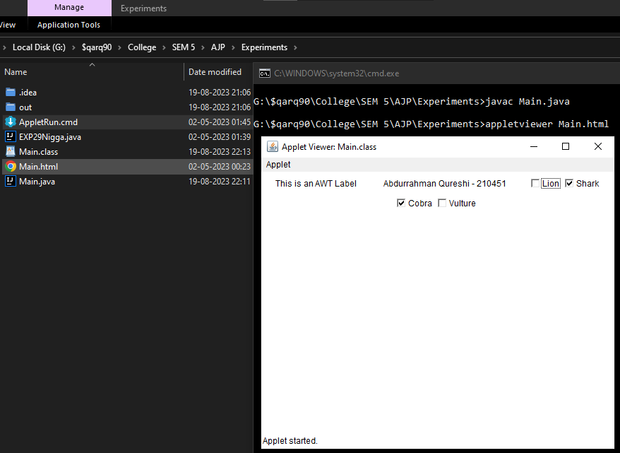

**2)Demonstrate the use of TextField , Textarea and Button**

**CODE:**

import java.applet.*;

import java.awt.*;

// <applet code="Main" height=200 width=200></applet>

public class Main extends Applet{

TextField tf;

TextArea ta;

Button b;

Label l2;

public void init(){

l2 = new Label("\t\tAbdurrahman Qureshi - 210451");

tf = new TextField("This is a TextField demo");

ta = new TextArea("This is a TextArea demo \nWe can place multiple lines here",3,2);

b = new Button("A button");

setLayout(new GridLayout(3,0));

add(l2);

add(tf);

add(ta);

add(b);

}

}

**OUTPUT:**

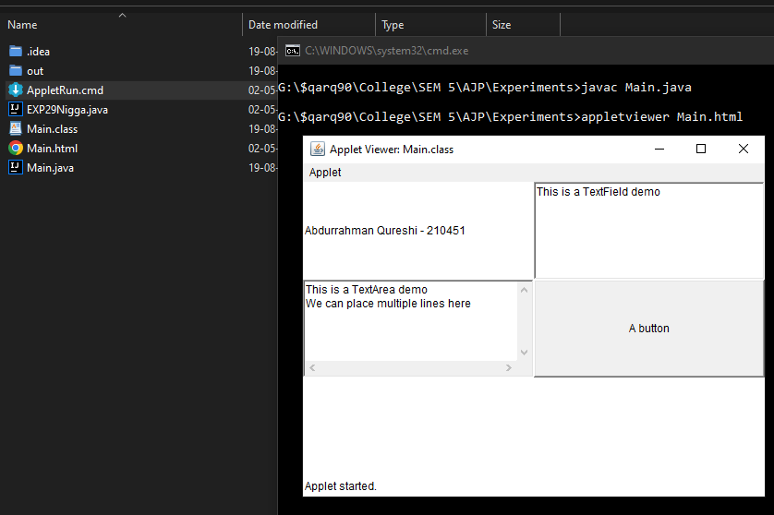

**3)Display some text using a Label**

**CODE:**

import java.applet.*;

import java.awt.*;

// <applet code="Main" height=200 width=200></applet>

public class Main extends Applet{

Label l2,l1;

public void init(){

l2 = new Label("Abdurrahman Qureshi - 210451");

l1 = new Label("wut d dawg doin?");

add(l2);

add(l1);

}

}

**OUTPUT:**

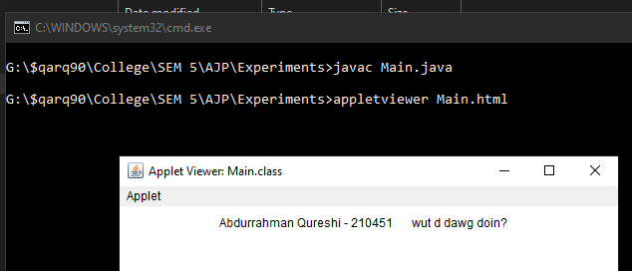

**4)Give user choice between selecting multiple languages**

**CODE:**

import java.applet.*;

import java.awt.*;

// <applet code="Main" height=200 width=200></applet>

public class Main extends Applet {

Checkbox c1, c2, c3, c4;

Label l2, l1;

public void init() {

l2 = new Label("Abdurrahman Qureshi - 210451");

l1 = new Label("languages: ");

c1 = new Checkbox("English", true);

c2 = new Checkbox("Hindi", false);

c3 = new Checkbox("Marathi", false);

c4 = new Checkbox("Sanskrit", false);

setLayout(new GridLayout(6,1));

add(l2);

add(l1);

add(c1);

add(c2);

add(c3);

add(c4);

}

}

**OUTPUT:**

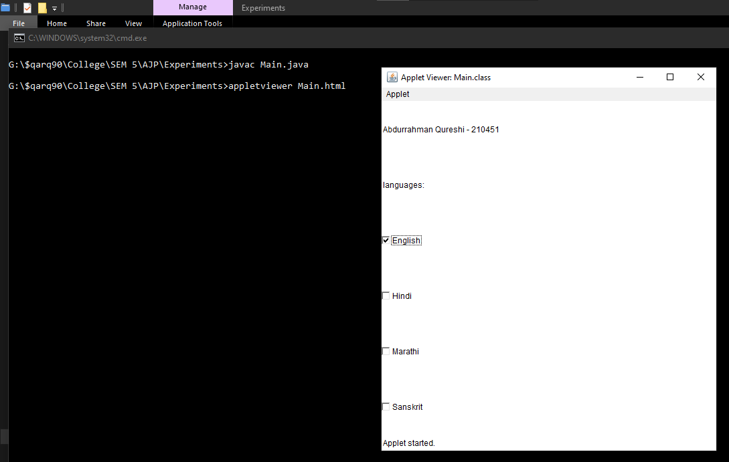

**5)Create three buttons with caption OK, RESET and CANCEL**

**CODE:**

import java.applet.*;

import java.awt.*;

// <applet code="Main" height=200 width=200></applet>

public class Main extends Applet {

Button c1, c2, c3, c4;

Label l2;

public void init() {

l2 = new Label("\t\tAbdurrahman Qureshi - 210451");

c1 = new Button("\t\tOK");

c2 = new Button("\t\tRESET");

c3 = new Button("\t\tCANCEL");

setLayout(new GridLayout(4, 1));

add(l2);

add(c1);

add(c2);

add(c3);

}

}

**OUTPUT:**

